**PH233 End-semester exam Module B: Sensor and PLANT**

We use an NPN phototransistor (ST1KL3B) as the light sensor.  
The Emitter current of the phototransistor is directly proportional to the light falling on it’s Base terminal. Design a circuit to convert this Emitter current to an output voltage (as used before in Lab 3.2)

Design constraint is that the output voltage from the phototransistor circuit should not saturate at maximum limit of incident light.   
Choose a conservative value of the emitter resistance to fulfil this design constraint.

**Objective of Module B: Characterize the PLANT**

**In the feedback control system used for this experiment, the LED actuator + Sensor (phototransistor) combined together constitute the PLANT**

Hence we need to characterize the PLANT by controlling the incident light with the actuator module LED driver circuit (Module A), and measuring the voltage response from the phototransistor Sensor.

Mount the LED and phototransistor facing each other on your breadboard. Distance between them should be as small as possible. Insert the two devices into two ends of a short piece of straw painted black as shown in the diagram below:

Breadboard

LED

SENSOR

Fig 2: Piece of straw painted black slipped onto your LED and sensor at each end helps to reject external light disturbance on your setup during characterization

**Aim of circuit demo:**

Check the following things with the LED + sensor setup as in Fig 2:

When Vin|actuator is minimum → Vout|sensor is minimum  
When Vin|actuator is maximum → Vout|sensor is maximum *and not saturated*

The relation between Vin|actuator and Vout|sensor is approximately linear

Make measurements as per the following pattern: **5**

Vin|actuator = 0V Vout|sensor = 0V

Vin|actuator = 1V Vout|sensor = 1.03V

Vin|actuator = 2V Vout|sensor = 2.06V

Vin|actuator = 3V Vout|sensor = 3.11V

Vin|actuator = 4V Vout|sensor = 4.03V

What is your measured proportional relation $\frac{V_{out|sensor }}{V_{in|actuator}}$ in the middle of your range?

Proportion constant in middle of range = 2.06/2 = 1.03

We already know from measurements of the first column in Module A (Vin|actuator) that ILED and hence the LED brightness increases proportionately. The aim of the above measurements is to ensure that the values in the right column also follow proportionately: the last two row values of Vout|sensor should not be close together, indicating saturation. If they are, adjust the emitter resistance for the phototransistor accordingly to obtain approximately proportional behavior.

In the next module with feedback, we will be working in the central part of the above range around 2V with small disturbances, so it is especially important that the actuator→sensor mapping is close to linear around 2V.

Emitter resistance for the phototransistor = 10kΩ.

Post photos of your plant setup here (LED + phototransistor) with DMM measurements of voltages in the above table at 1V,2V,3V **5**

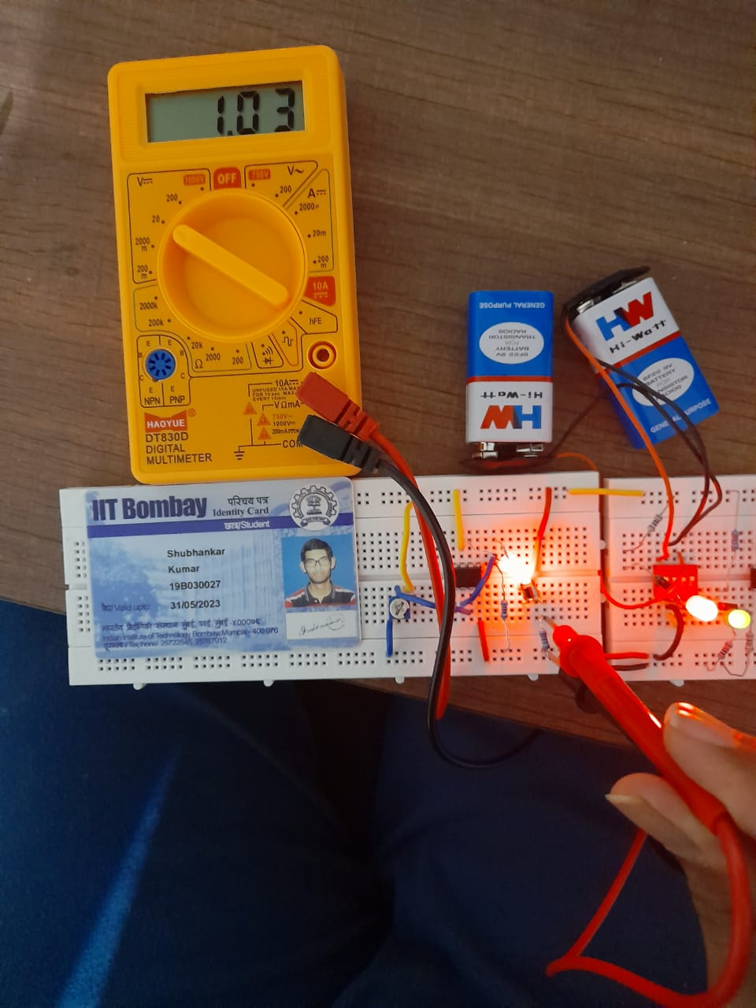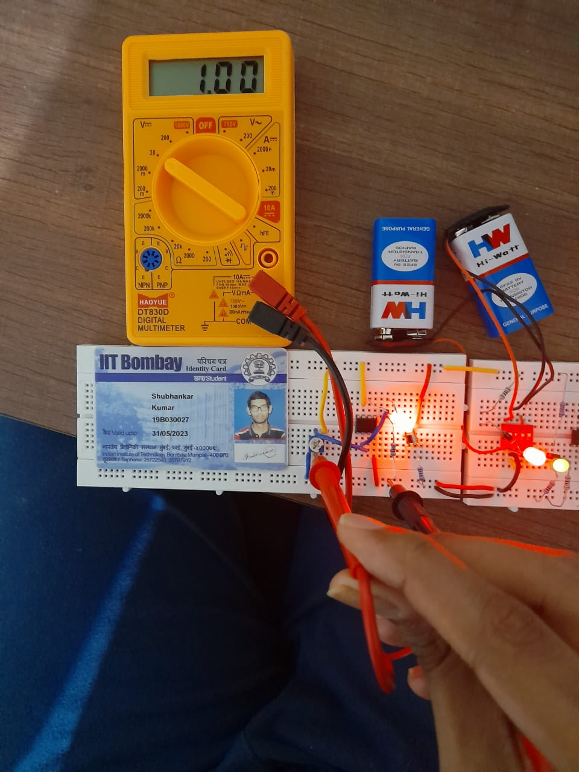

**VIN = 1V VOUT = 1.03V**

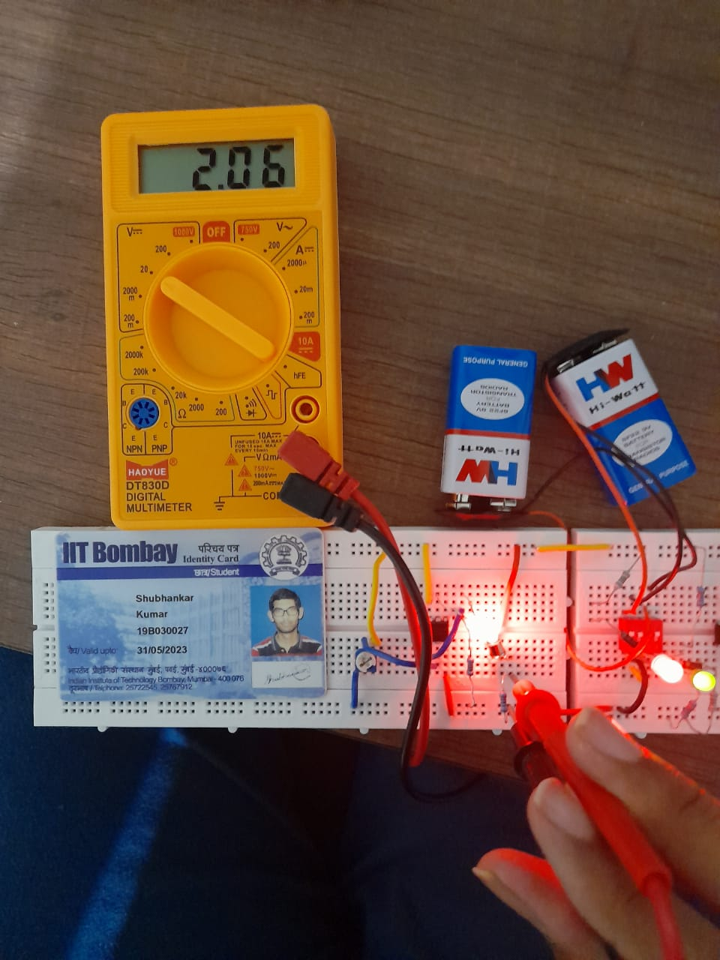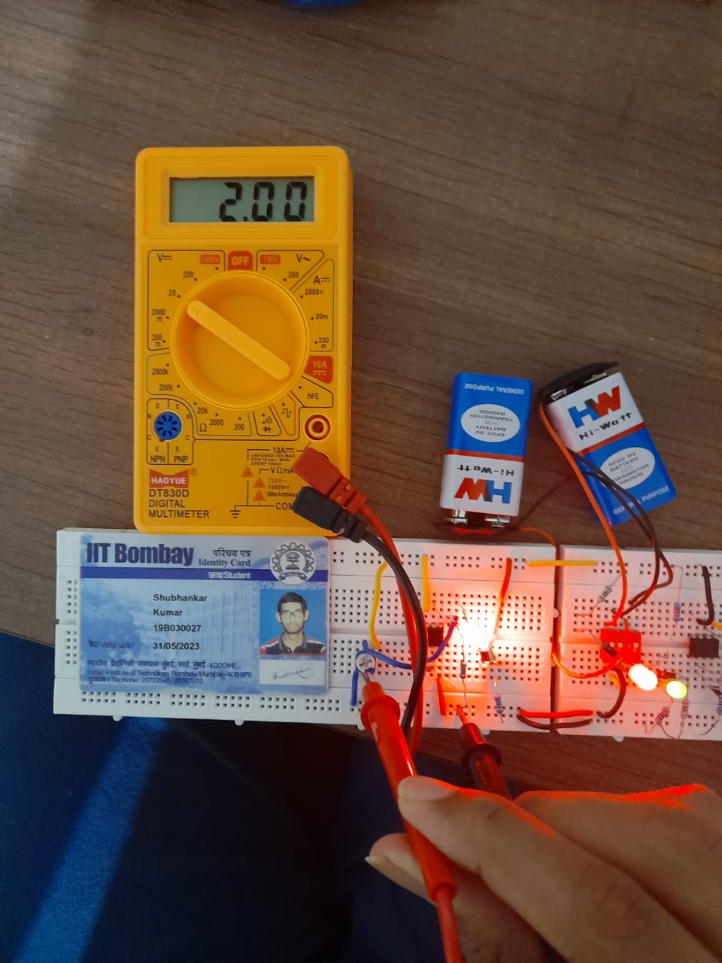

**VIN = 2V VOUT = 2.06V**

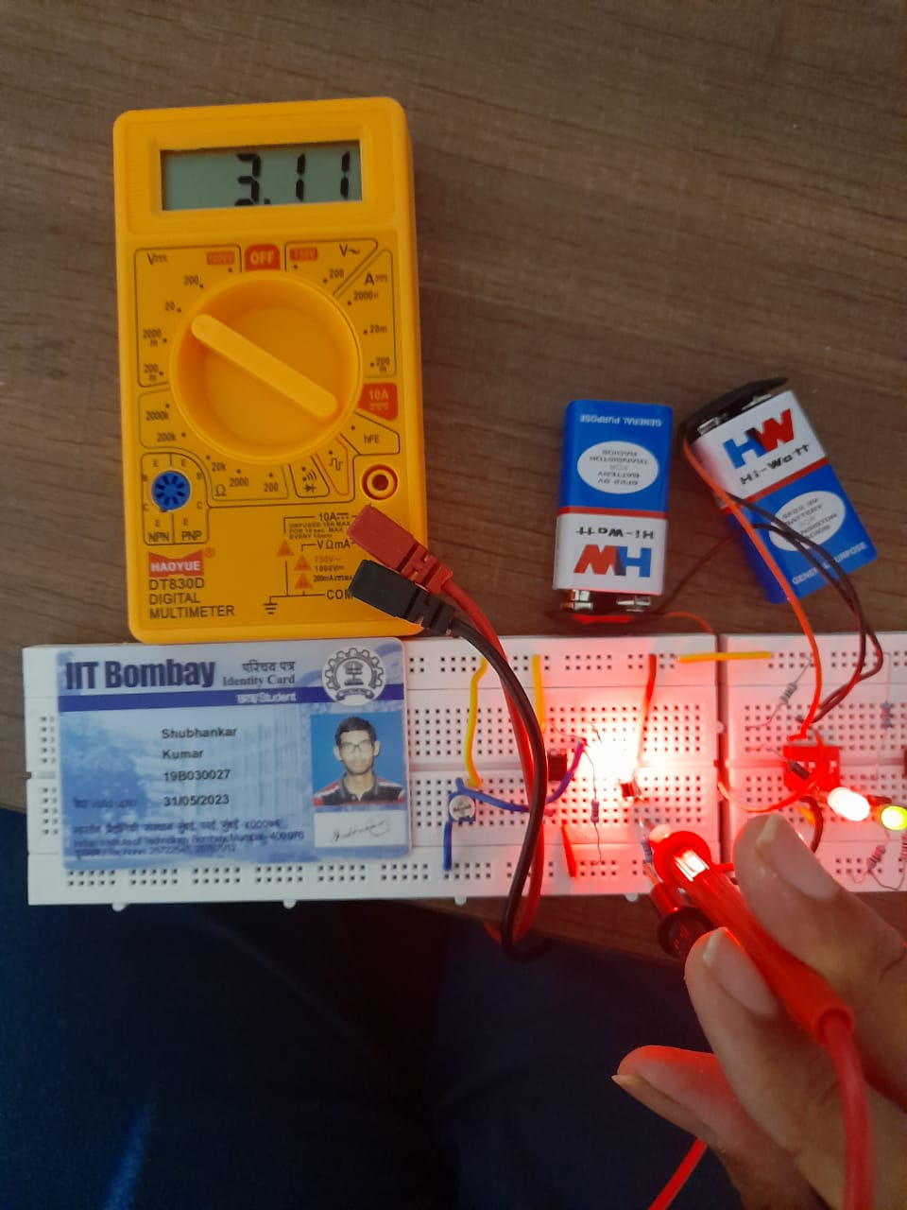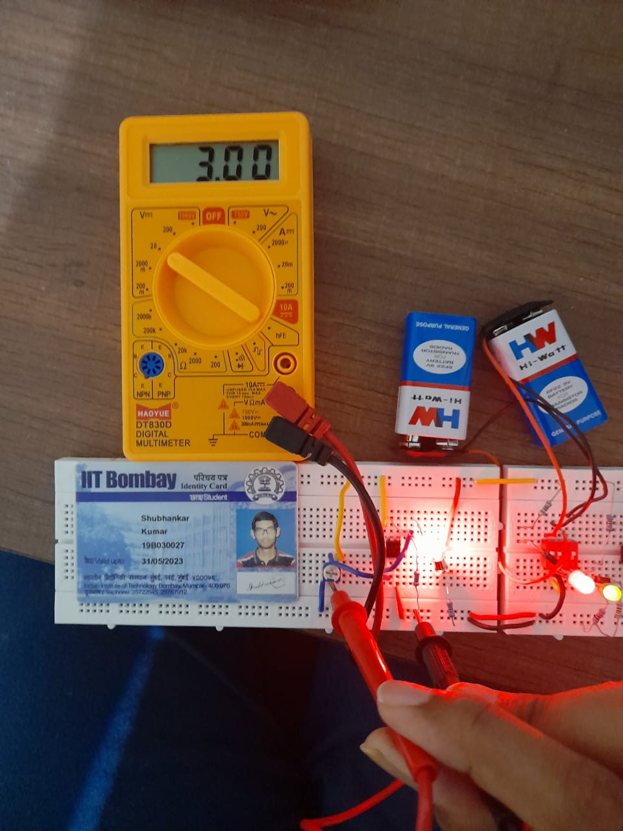

**VOUT = 3V VOUT = 3.11V**